Secure Settings
Select Options Procedure

Revision
Version 3
9/8/25 11:50 AM

SME
Charles Wilson

Abstract
This document describes the procedure used to perform the security option selection activity described in the AVCDL ^{[1]} secondary document Secure Settings Document ^{[2]}.

Group / Owner
Security / Security Architect

Motivation
This document is motivated by the need to ensure that the software is built with tools whose selected settings are based on cybersecurity best practices. This is necessary given the nature of safety-critical, cyber-physical systems
Note: Within the context of this document, the terms security and cybersecurity are used interchangeably. It is presumed that the term security is being used in reference to cybersecurity and not physical security.

License
This work was created by Torc Robotics and is licensed under the Creative Commons Attribution-Share Alike (CC BY-SA-4.0) License.
https://creativecommons.org/licenses/by/4.0/legalcode

Audience
The audience of this document is the cybersecurity practitioner who will be conducting element-specific tool cybersecurity options selection activity.

Completeness of Output
Since the element-specific selection of security options is an as-is analysis, it is critical to ensure that the information gathered is as accurate and complete as possible. As with any cybersecurity activity, it is not the place of the cybersecurity SME to make assumptions on the part of engineering. All information should be sourced from and confirmed by the owner of the element under consideration.
Note: When information is not available for either a given section of the template or parts thereof, this should be noted.

Disposition of Output
Once completed, the generated output should be managed in the organization’s document management system (DMS) as a document of record.

Entry Criteria
This document assumes that the reader understands the purpose of cybersecurity-relevant tool settings. Further, that the reader has read and understood the AVCDL Secure Settings Document secondary document.

Prerequisites – Security SME

Qualifications
It is required that the cybersecurity SME is both a qualified and trained security architect (shown above on title page as Owner) as defined by the NIST NCWF role SP-ARC-002 and detailed in section 12.7 Security Architect of the AVCDL primary document.

Knowledge
It is required that the cybersecurity SME understands the purpose of cybersecurity-relevant tool settings.

Background Information
It is required that the cybersecurity SME has read and understands the AVCDL Secure Settings Document ^{[2]} secondary document. Additionally, that the cybersecurity SME has taken training relevant to this activity.

Prerequisites – Development SME

Qualifications
It is required that the development SME is both a qualified and trained development SME with expertise in the element under consideration in the context of the tool under whose cybersecurity settings are being reviewed.
Note: The specific qualifications and training of development SMEs necessary to assert expertise in providing accurate information regarding the element under consideration is outside the scope of this document.
Note: The development group is responsible for determining and making available the appropriate SME for the analysis of the element under consideration.

Knowledge
It is required that the development SME have expertise in the element under consideration in the context of the tool under whose cybersecurity settings are being reviewed.

Prerequisites – Input Materials
It is required that the cybersecurity SME acquire all relevant documentation necessary to complete the procedure.

Select Security Options Activity
The workflow diagram for the select security options activity of the Secure Settings Document is shown below.
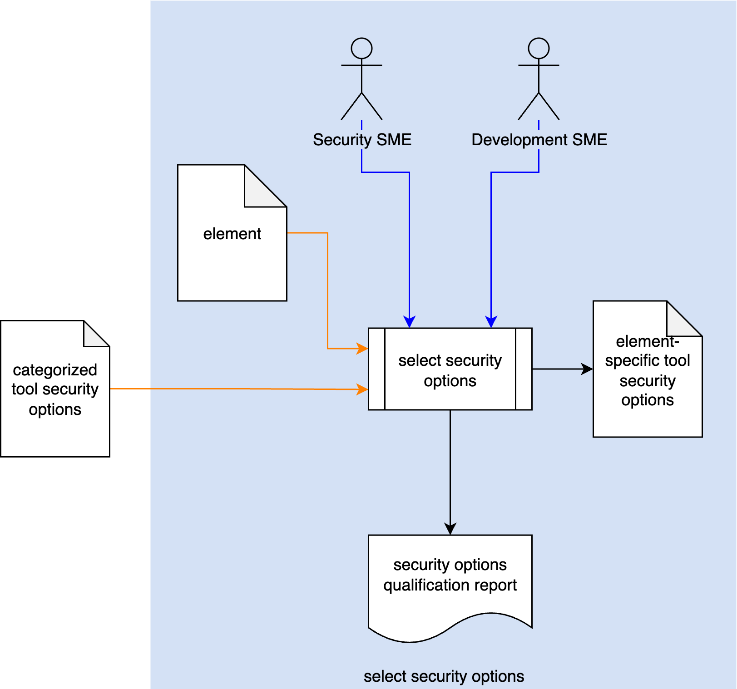
Using the Categorized Tool Security Options and Element under consideration, the Security SME and Development SME select applicable security options to be applied to the Element. An Element-specific Tool Security Options list is generated. A Security Options Qualification Report is generated.
Note: If an option is not used, the justification for not selecting it must be documented.

Methodology
The methodology to be used for selection of element-specific tool cybersecurity options is straightforward. The cybersecurity SME and development SME review each option in turn and either disposition it for inclusion or exclusion. In cases where an option is excluded a justification must be provided by the development SME.
The Categorized Tool Security Options list should provide sufficient information for the cybersecurity SME to be able to justify the utility of each option.
Note: Depending on the tool under consideration, the options should be organized by the cybersecurity engineer to focus on those with the greatest cybersecurity impact. This implies a further refinement of the options list beyond that of categorization may be required.
There are various reasons why options may be excluded. These include (but are not limited to):
- Element source not being modifiable
- Option not being applicable to the element (most commonly in static analysis)
- Option use consumes excessive time

Element-specific Tool Options Template
The tool’s selected cybersecurity-relevant option information may be documented using the AVCDL element-specific tool cybersecurity options template Microsoft Excel workbook ^{[3]}.
Note: Other forms of documentation are permissible so long as they provide the information laid out in this document.
There are five sheets in the workbook. They are:
- Cover sheet
- Revision history
- Reference documents
- Option Selection
- Legend
These will be addressed in turn.

Duplication of Rows in the Various Sheets
When there is the need to add rows to the various sheets of the workbook, be sure to duplicate an existing row. This is because validation checks are attached to some of the cells which also enables the use of dropdown lists.

Cover Sheet
The cover sheet of the workbook is shown below:
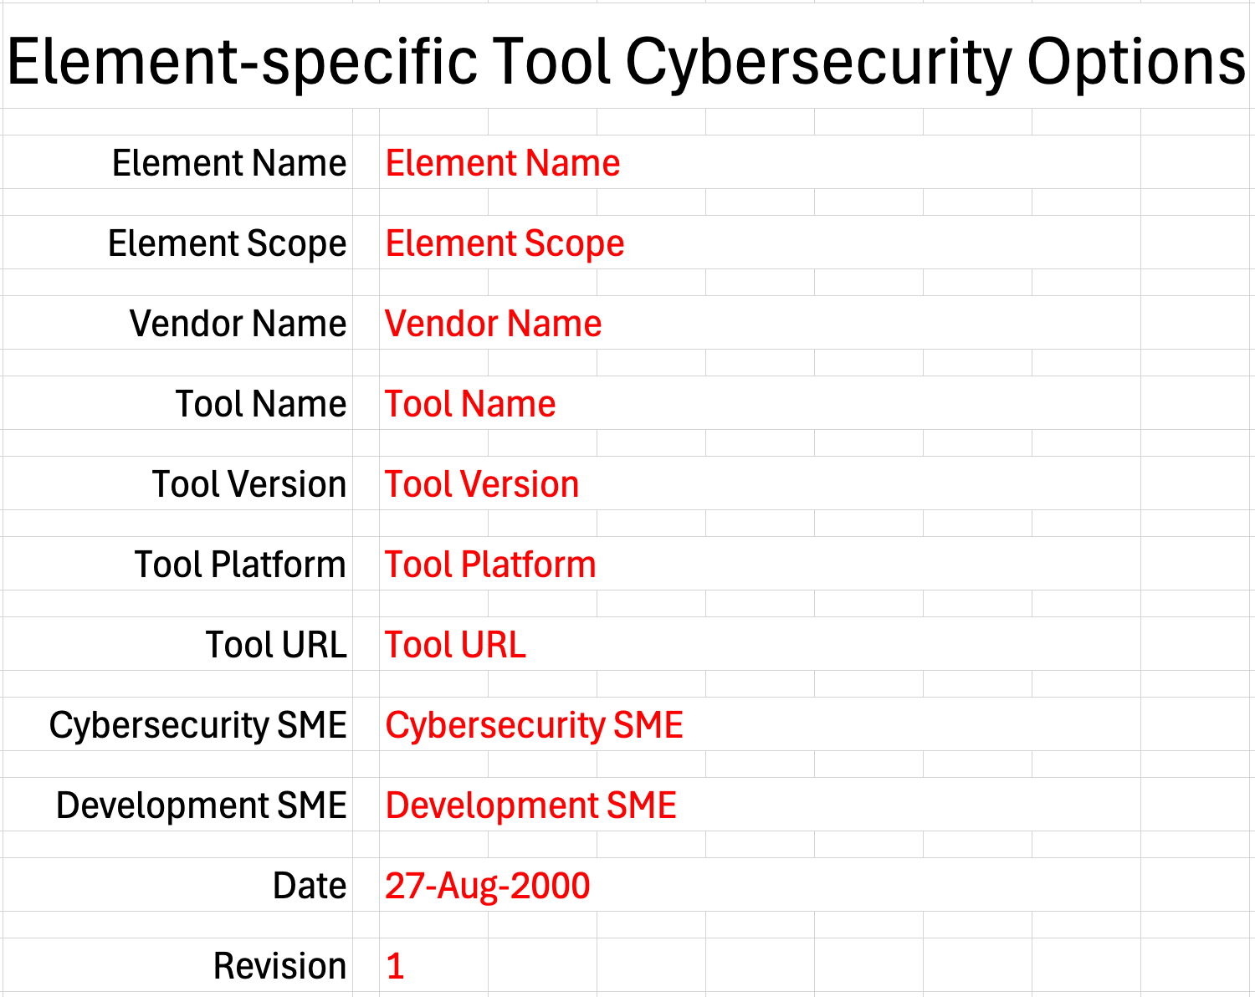
Fields to be completed are shown in red.

Element Name
The element name is the element to which the tool will be applied.

Element Scope
The scope of the element is left to the discretion of the customer. Examples of element scopes include system, sub-system, component, component software (non-OS), and component OS.
Note: In this context, the customer refers to the entity requiring the activity.

Vendor Name
This is the name of the vendor responsible for the element being modeled.

Tool Name
This is the name of the tool whose cybersecurity options are being identified.

Tool Version
This is version number of the tool under consideration.

Tool Platform
This is the platform on which the tool is run.

Tool URL
This is location where the tool can be found.

Cybersecurity SME
This is the cybersecurity subject matter expert creating the option selection list.

Development SME
This is the development subject matter expert providing element-specific tool usage information necessary for the selection of the identified cybersecurity options.

Date
This is the date when the options list was created or updated. The date should be updated whenever the list is updated.

Revision
This is the revision number of the document. The revision number is a monotonic and increasing integer, starting at 1. It should be incremented every time the document is updated.

Revision History
The revision history sheet of the workbook is shown below:
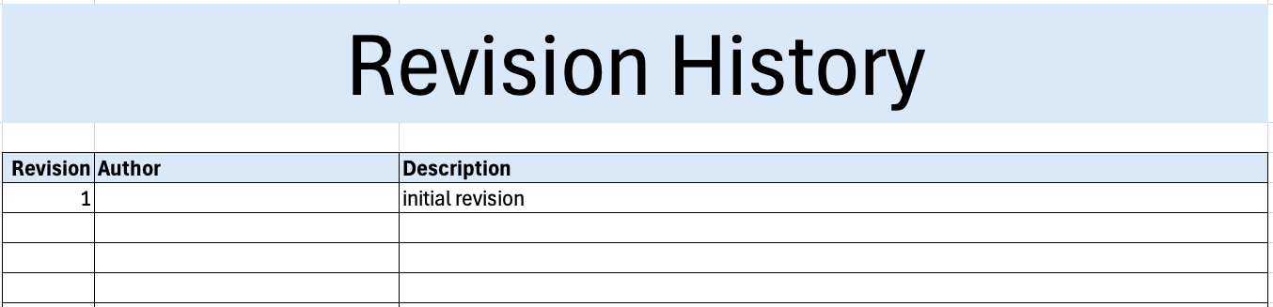

Revision
The revision corresponds to that listed on the cover sheet.

Author
The author corresponds to the cybersecurity SME listed on the cover sheet.

Description
This is a brief description of changes made to the document since it was last updated.

Reference Documents
Note: References relevant to the selection of the cybersecurity options should be added to this list.
The references sheet of the workbook is shown below:
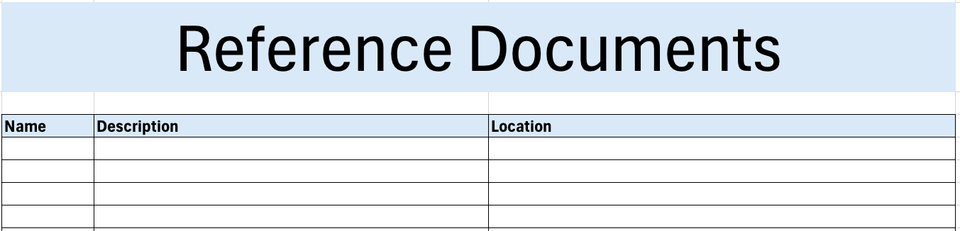

Name
This is the name of the document being referenced.

Description
This is a brief description of the document being referenced.
Note: In cases where the reference material is expressed in the form other than a document (for example, a web page), this should be noted.

Location
This is the location of the document being referenced. It may be a physical location or a URL.

Option Selection
The option selection sheet of the workbook is shown below:
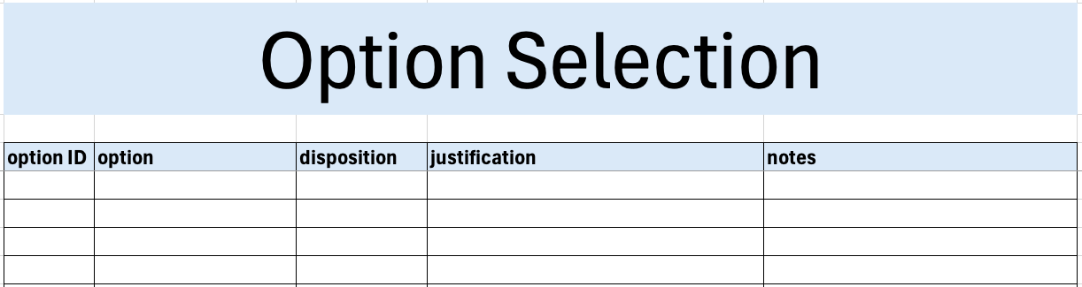

Option ID
This is the unique ID of the option.

Option
This is the name of the option.
Note: the option and option ID are sourced from the Categorized Tool Security Options list. This may be documented using the AVCDL tool cybersecurity options template ^{[5]} Microsoft Excel workbook. Additional information can be found in the Secure Settings – Identify Options Procedure ^{[4]} AVCDL tertiary document.

Disposition
This is the disposition of the option. The option may either be included or excluded.

Justification
This is the justification for why an option has been excluded from use.
Note: This is an optional field. It must be provided only when an option has been excluded from use.

Notes
This is a general notes field.

Legend
The legend sheet of the workbook is shown below:
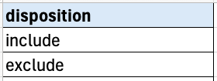
The legend sheet information is used to make the completion of the document easier by providing dropdown lists for common values. It also ensures that spelling errors do not creep into the generated material.
Note: The legend sheet should not be edited. If an unlisted value is required, the template should be separately revised.

Exit Criteria
This procedure is considered complete once the generated output has been entered into the organization’s DMS as a document of record.
Note: The processes and procedures for entering documents into the DMS, or the updating thereof, are outside the scope of this document.

References
- AVCDL (AVCDL primary document)
- Secure Settings Document (AVCDL secondary document)
- AVCDL element-specific tool cybersecurity options template (AVCDL template)
- Secure Settings – Identify Options Procedure (AVCDL tertiary document)
- AVCDL tool cybersecurity options template (AVCDL template)

